**Reports:**

* Reports in Salesforce is a list of records that meet a particular criterion which gives an answer to a particular question. These records are displayed as a table that can be filtered or grouped based on any field.

There are 4 types of report formats in Salesforce:

**1.Tabular Reports:**

This is the most basic report format. It just displays the row of records in a table with a grand total. While easy to set up they can’t be used to create groups of data or charts and also cannot be used in Dashboards. They are mainly used to generate a simple list or a list with a grand total.

**2.Summary Reports:**

It is the most commonly used type of report. It allows grouping of rows of data, view subtotal, and create charts.

**3.Matrix Report:**

It is the most complex report format. Matrix report summarizes information in a grid format. It allows records to be grouped by both columns and rows. It can also be used to generate dashboards. Charts can be added to this type of report.

**4.Joined Reports:**

These types of reports let us create different views of data from multiple report types. The data is joined reports are organized in blocks. Each block acts as a sub report with its own fields, columns, sorting, and filtering. They are used to group and show data from multiple report types in different views.

**Report types:**

* Report type determines which set of records will be available in a report. Every report is based on a particular report type. The report type is selected first when we create a report. Every report type has a primary object and one or more related objects. All these objects must be linked together either directly or indirectly.

1.A Report type cannot include more than 4 objects.

2.Once a report is created its report type cannot be changed.

* There are 2 types of report types:

**1.Standard Report Types:**

* Standard Report Types are automatically included with standard objects and also with custom objects where “Allow Reports” is checked.
* Standard report types cannot be customized and automatically include standard and custom fields for each object within the report type. Standard report types get created when an object is created, also when a relationship is created.

**2.Custom Report Types:**

* Custom report types are reporting templates created to streamline the reporting process. Custom Reports are created by an administrator or User with “Manage Custom
* Report Types” permission. Custom report types are created when standard report types cannot specify which records will be available on reports.
* In custom report types we can specify objects which will be available in a particular report.
* The primary object must have a relationship with other objects present in a report type either directly or indirectly.
* There are 3 types of access levels of folders:

**1.Viewer:**

With this access level, users can see the data in a report but cannot make any changes except cloning it into a new report.

**2.Editor:**

With this access level, users can view and modify the reports it contains and can also move them to/from any other folders they have access level as Editor or Manager.

**3.Manager:**

With this access level, users can do everything Viewers & Editors can do, plus they can also control other user’s access levels to this folder. Also, users with Manager Access levels can delete the report.

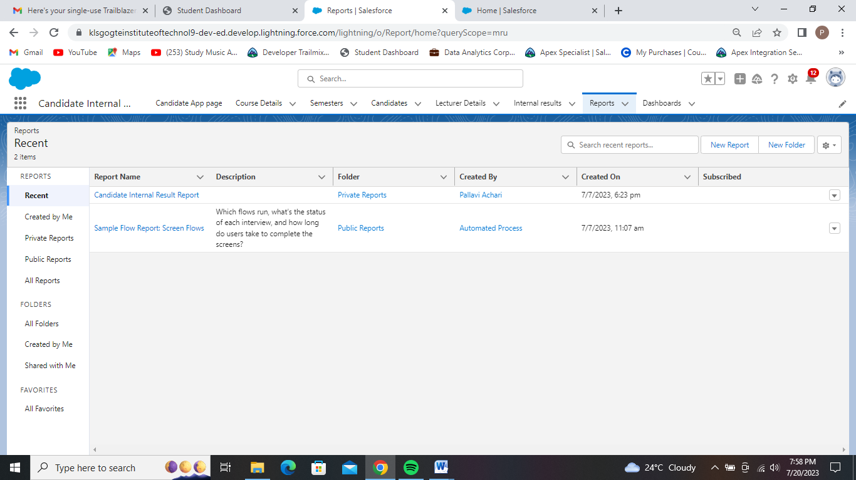

Report Tab Page.

* Here we have created reports for Candidate Internal Report Card App.
* Selected report type as Semesters with Course Details
* For group rows we selected ‘Course Name’ and for in group column Selected Duration.
* And given the Given the report name as Candidate Internal Result Report.

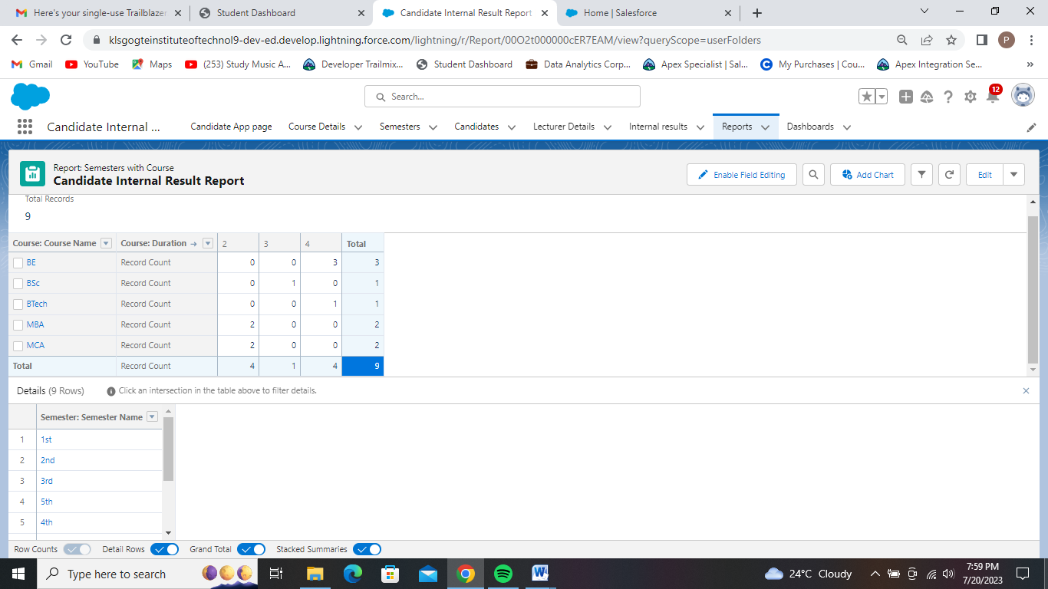

Candidate Internal Result Report.

**Dashboards :**

* Dashboards let you curate data from reports using charts, tables, and metrics. If your colleagues need more information, then they're able to view your dashboard's data-supplying reports. Dashboard filters make it easy for users to apply different data perspectives to a single dashboard.

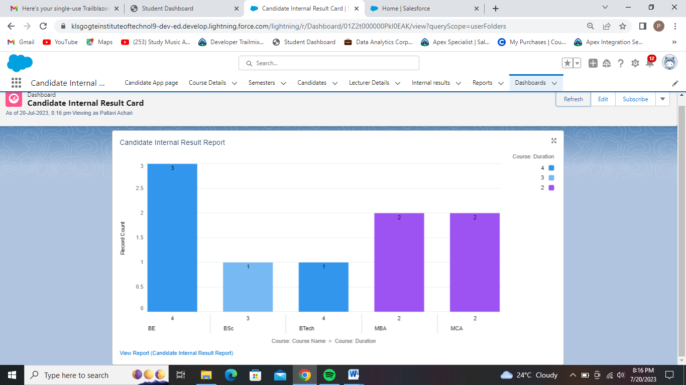

Dashboard for candidate Internal Result Card App.